**Gracious Germents**

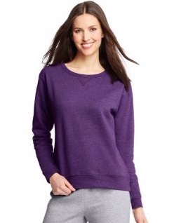

**DESCRIPTION:**

Comfort never had it so good.

At Hanesbrands Inc., our EcoSmart® products keep the equivalent of nearly 50 million plastic bottles from landfills each year.

Soft, 7.5oz cotton blend provides comfort in any climate.

Ribbed hem and cuffs keep their shape.

High-stitch density, so it lasts longer without pilling.

Tag-free for added comfort.

Available in a variety of colors.

Units Per Pack: 1

Fabric Content: 250 gram, 50% Cotton, 50% Polyester

Country of Origin: Imported

**ADDITIONAL INFORMATION**

Weight: 0.5 kg

Dimensions: 10 × 8 × 3 cm

Size: S, M, L, XL,

Price: $20.00